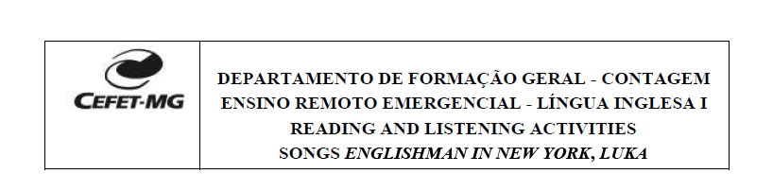

Nome: Felipe Augusto do Nascimento

Turma: Info-1

1. Where is he (the persona in the song)? R: He is a New York.

2. Where is he from? R: He is from Inglaterra.

3. What are his cultural habits according to the lyrics? R: He doesn’t drink coffee, favorite drink tea and like toast done on one side.

4. Search the word “alien” in a dictionary in English, such as www.dictionary.com or https://dictionary.cambridge.org/pt/ or https://michaelis.uol.com.br/moderno-ingles. Understand its meaning and answer the question: what does the author mena by saying “I’m an alien, I’m a legal alien, I’m an Englishman in New York”? R: Because he is an English in New York

5. Why does he say “Be yourself no matter what they say”? R: ??

6. And: “Takes more than a combat gear to make a man, takes more than a license for a gun.” Why does he say so? R:??